**CS551 Adv Software Engg**

**Assignment/Lab: 4**

Poojitha Mittapally,

16157740

**RestWebServices:**

In my application, I have shown an alert “Hello..!!, You are using REST web services” Upon clicking Click me button.

Link for my local host is : <http://localhost/aspnet_client/WcfService1/WcfService1/Service1.svc/newFun>

Which when opened in browser shows the json file as:

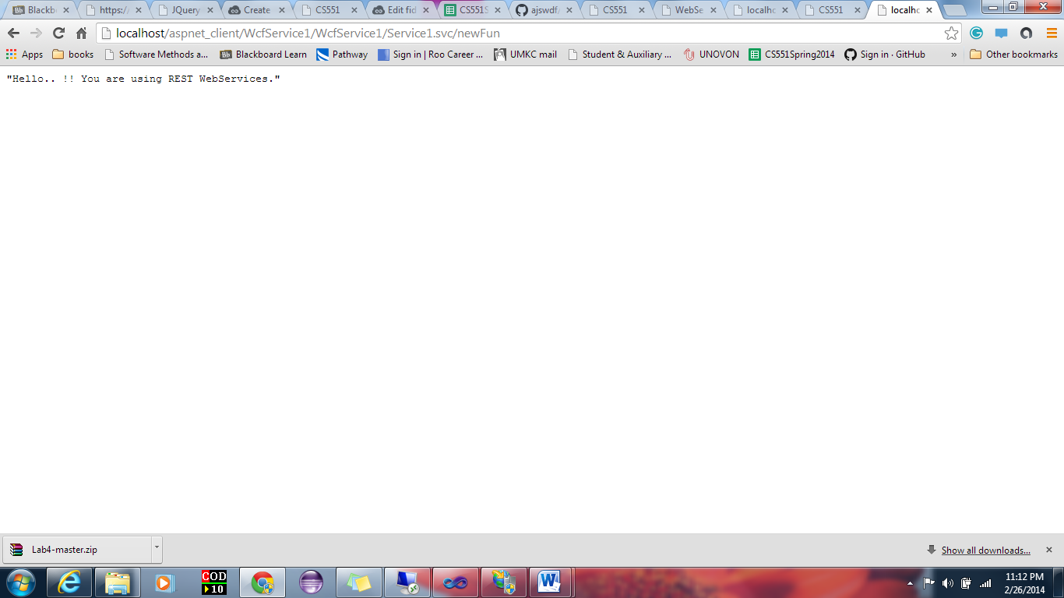

My application shows the page:

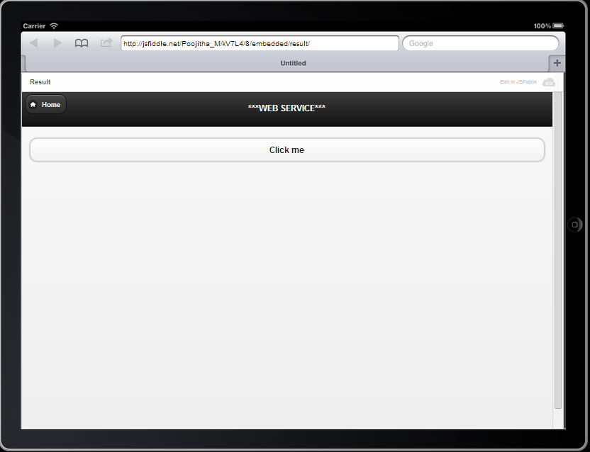

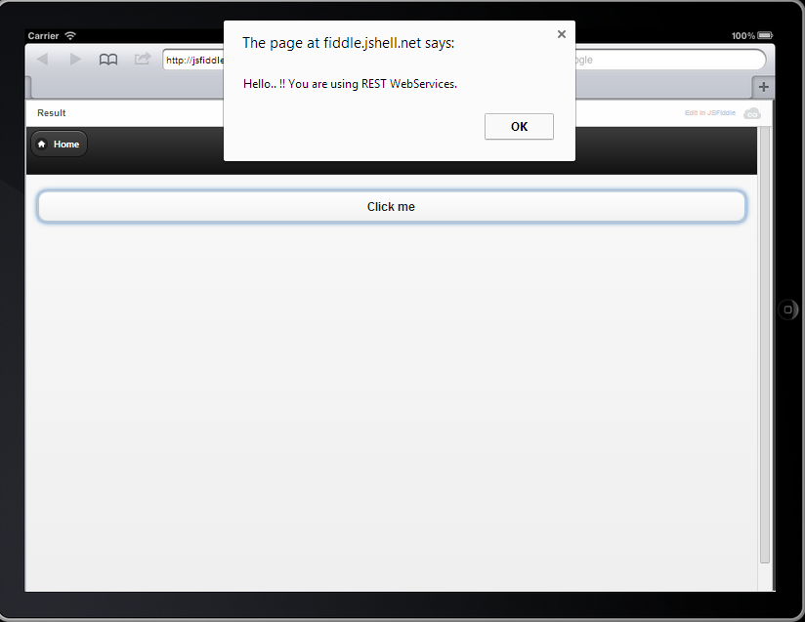

**Soap Web Service:**

I have written a location in c# file under <web method> The file is shown as this when opened in a browser.

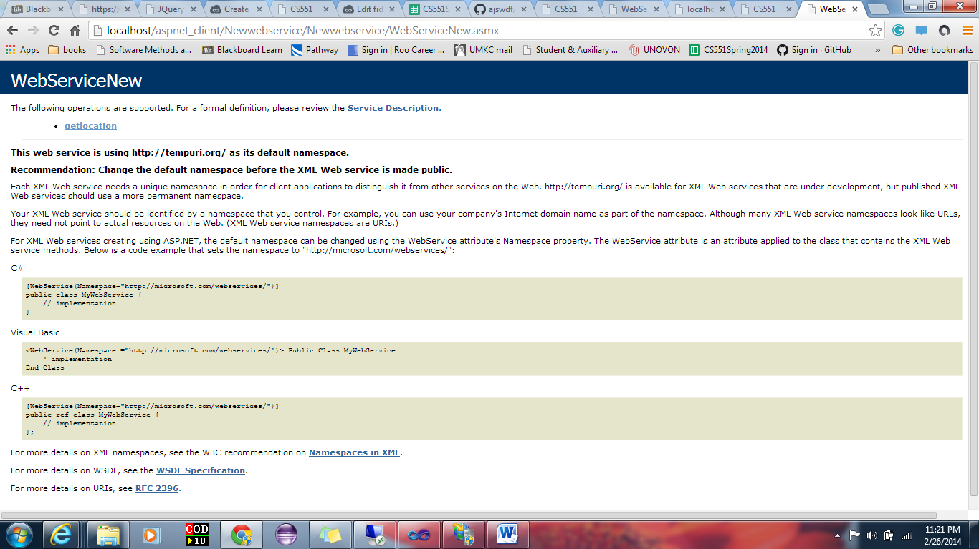

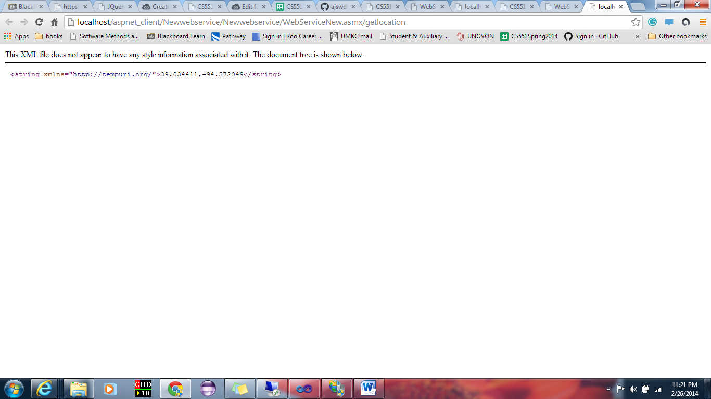

To call the soap web service, I have created a page like this. 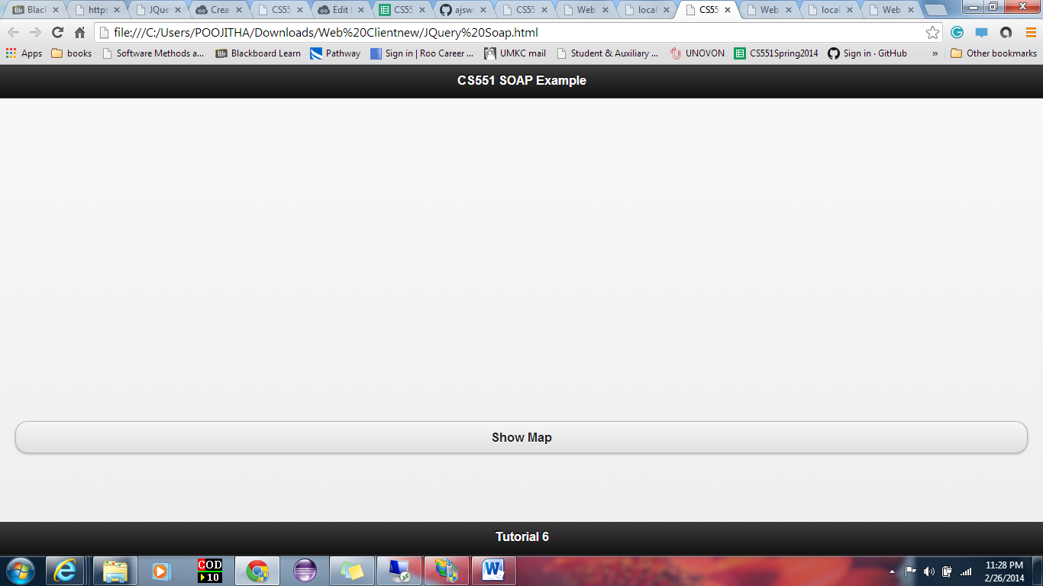

When I click on show map, it will give a javascript alert showing the location provided in c# file like the shown figure below.

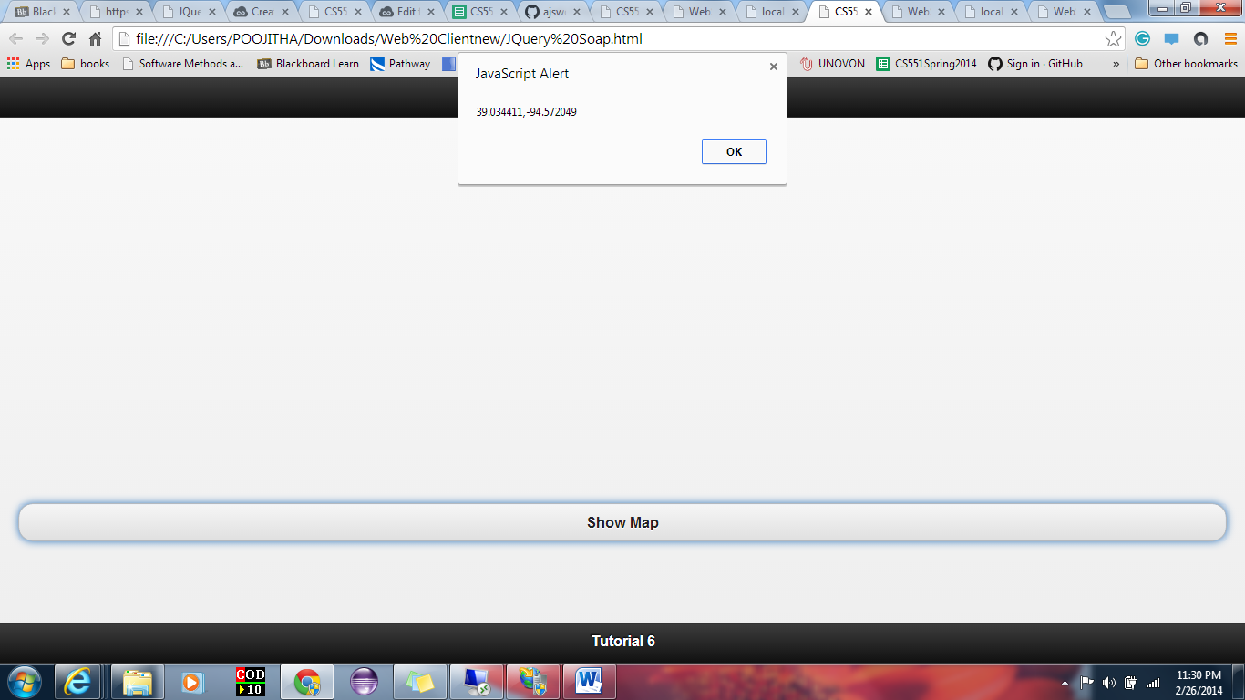

After clicking on “ok” button on alert, it will show the map locating the parameters in the center of the map.

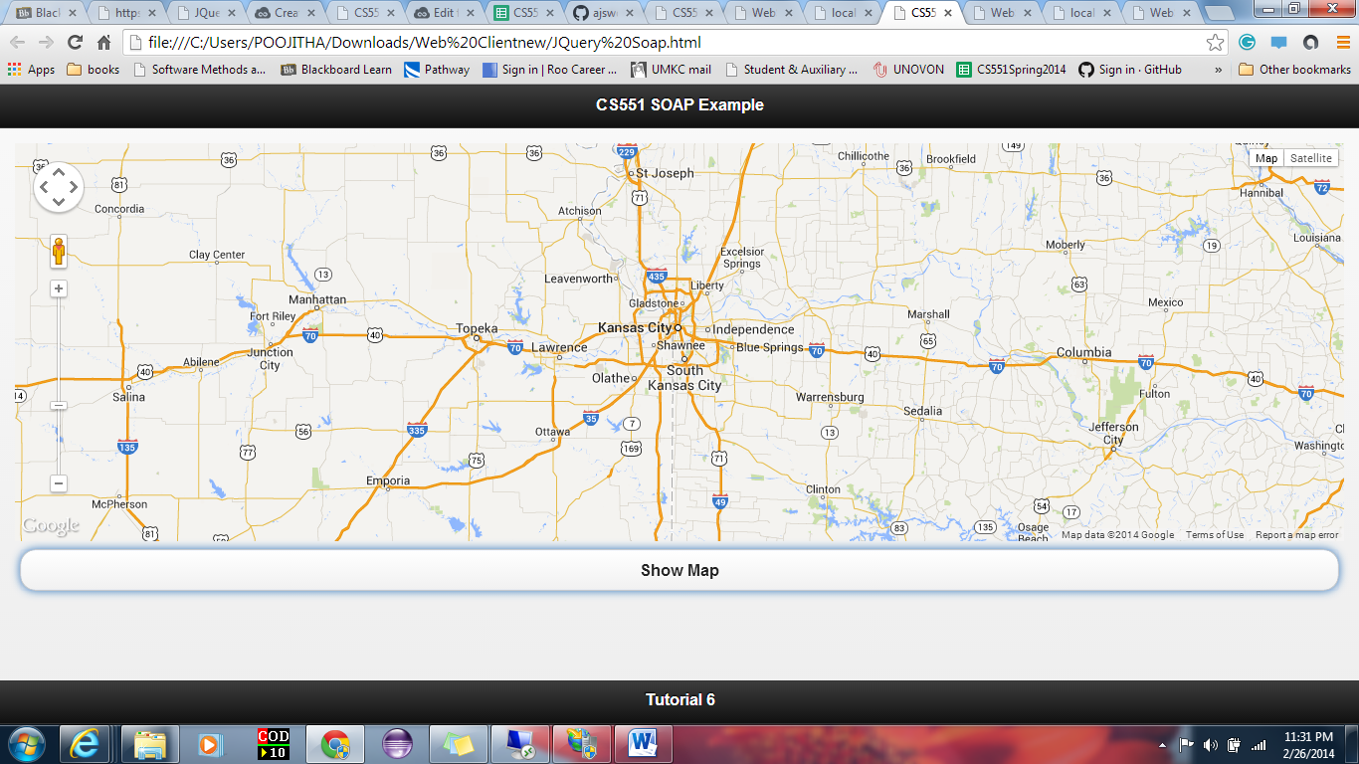

**2**. Web services for deleting, inserting and querying the table data is shown in the browser as:

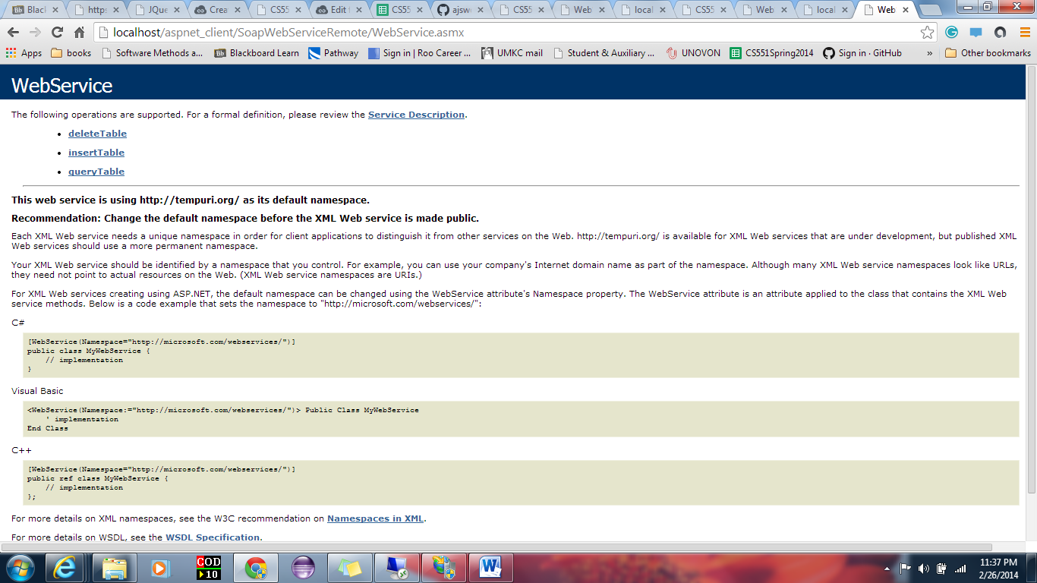

Here I am inserting my name into the table.

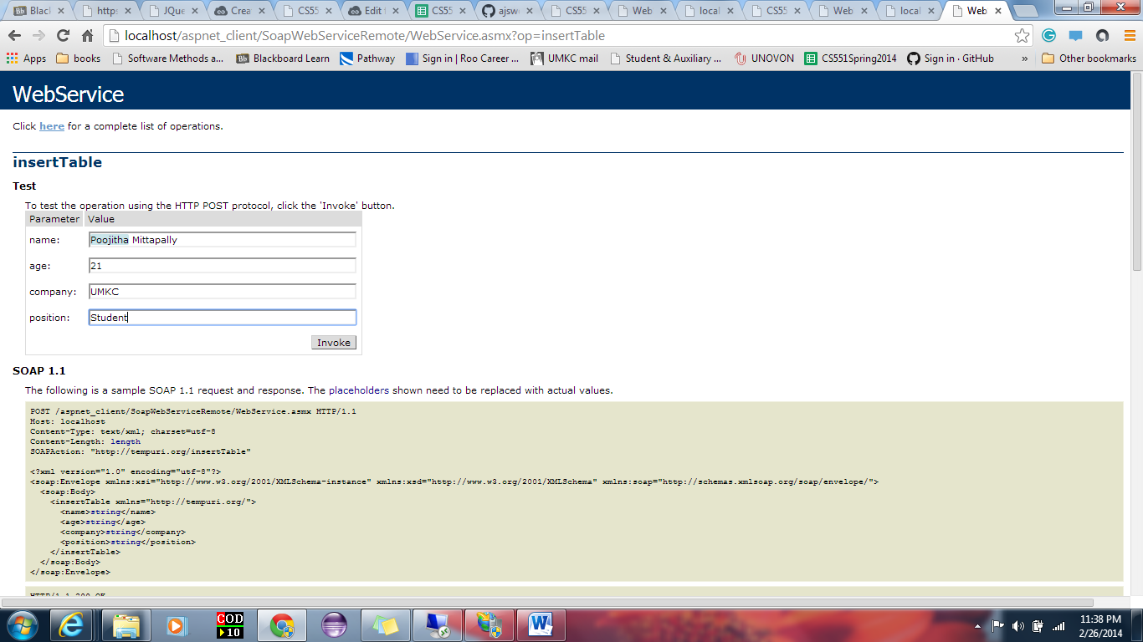

Likely we can delete and query the data from table.

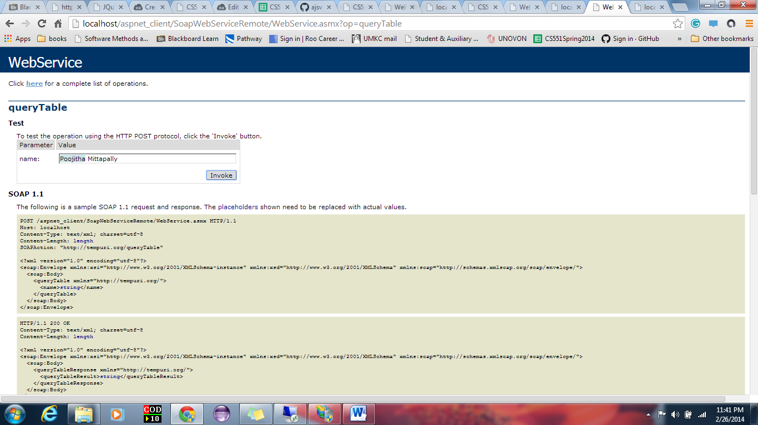

But I cannot modify in remote desktop as I don’t have authorization for IIS in it. I did this in my local desktop and found this partial result.

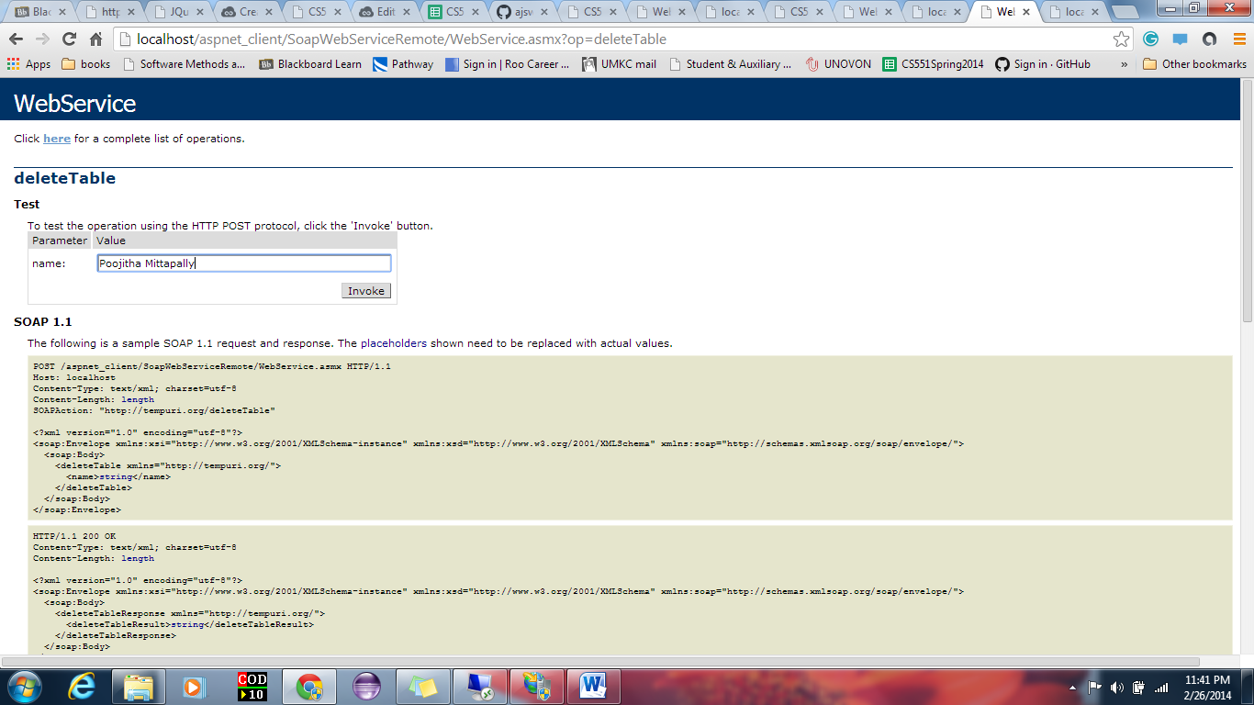

**3.** Android Web app calling soap web services.

I am getting error when I tried it in my local desktop.

